STAGE 1 — Install tools
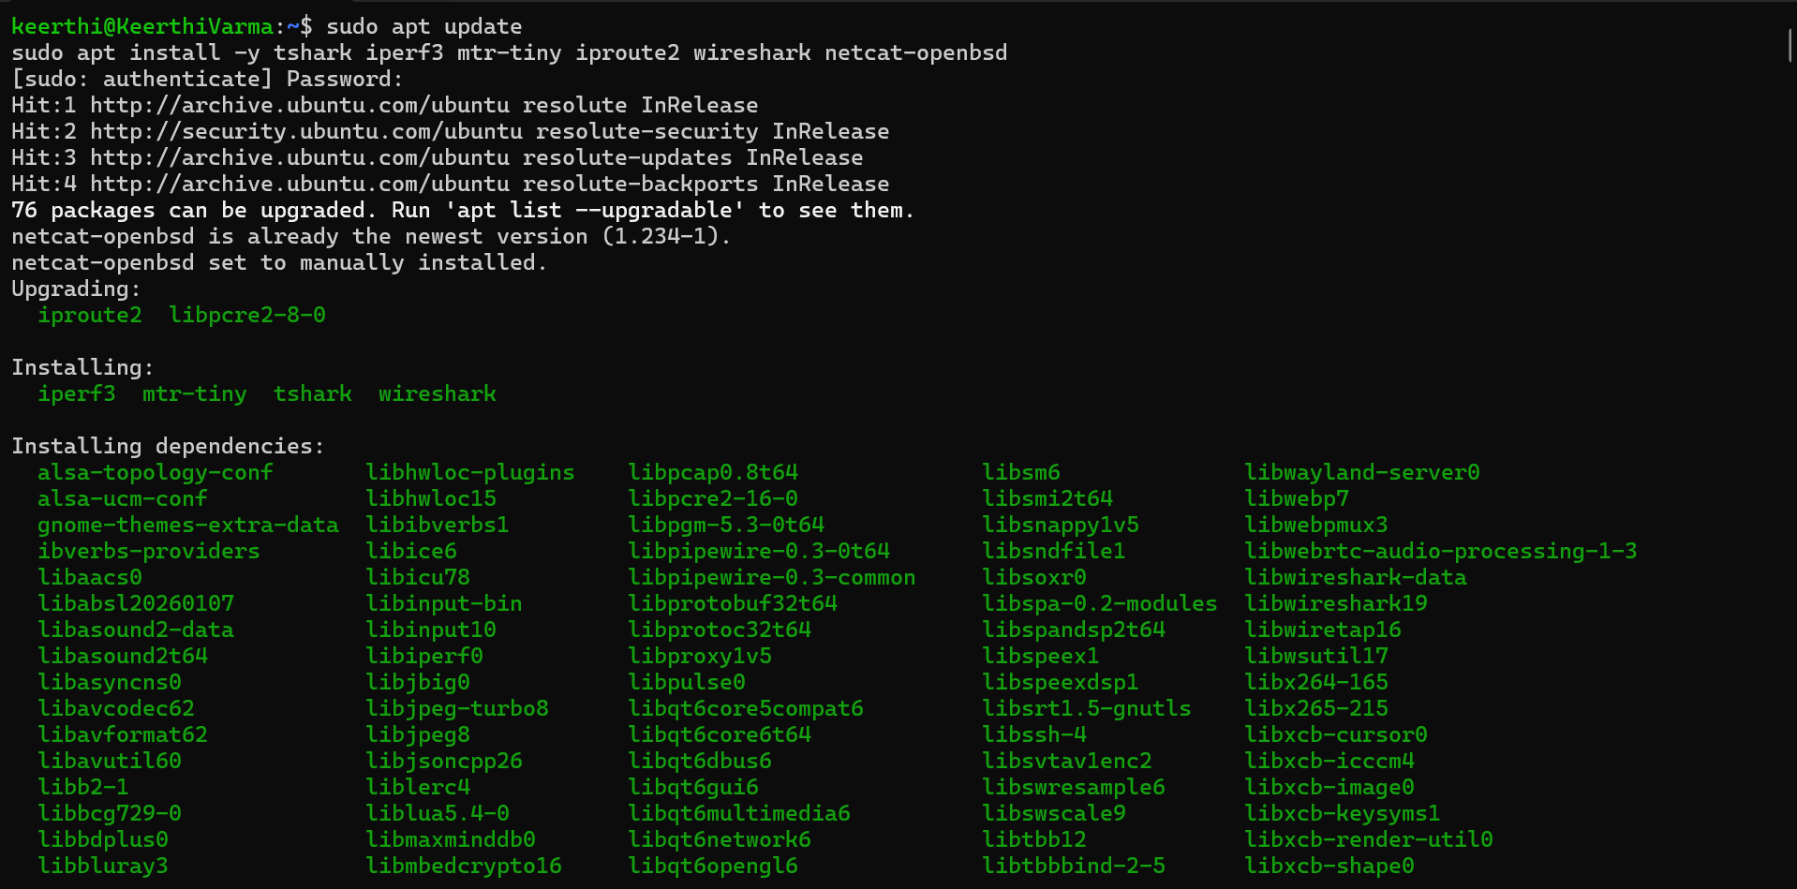
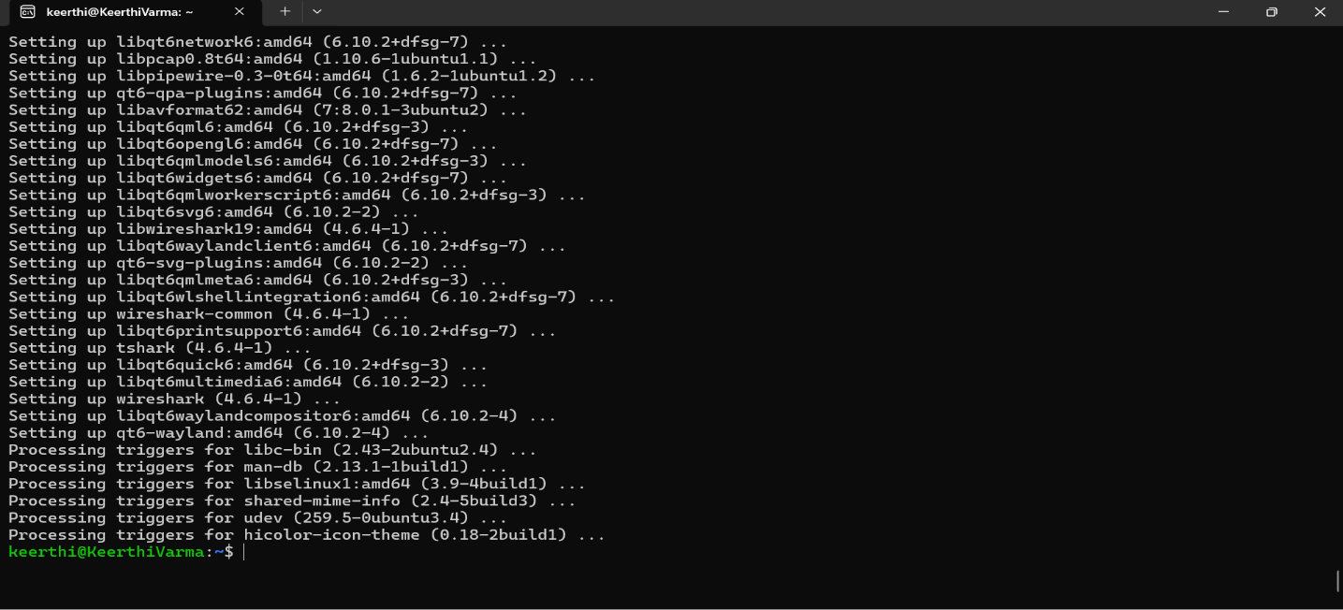
STAGE 2 — Build the network
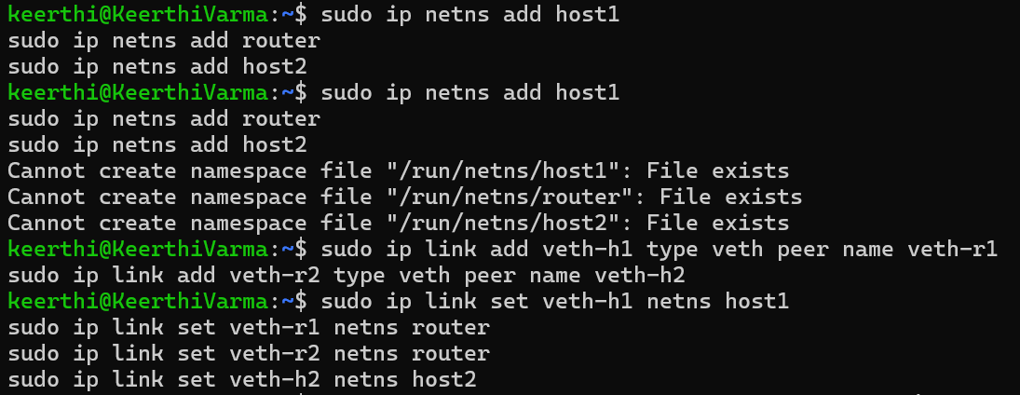

STAGE 3 — Configure IP addresses ( Note: In terminal 1 Only)
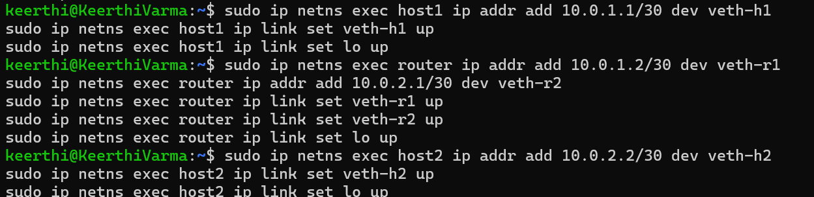
STAGE 4 — Enable routing
STAGE 5 — Test connectivity
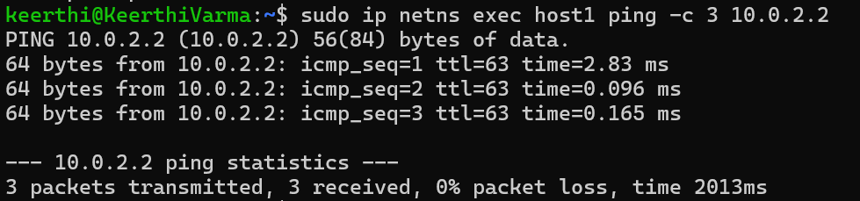
STAGE 6 — Add delay and loss
STAGE 8 — Start three captures simultaneously
Terminal 1 — capture at host1
Terminal 2 — capture at router
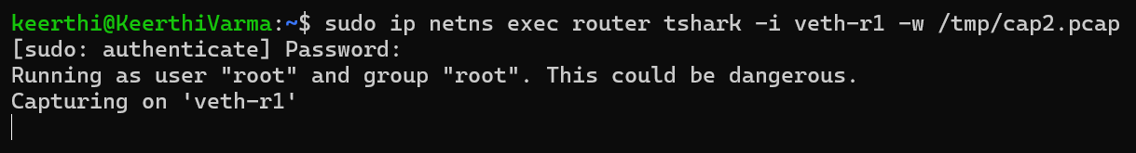

Terminal 3 — capture at host2
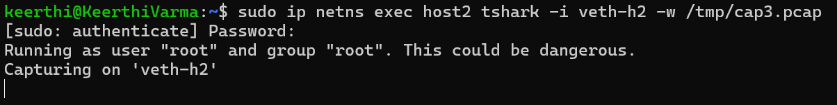
STAGE 9 — Send real message from host1 to host2
Terminal 4 - First start the receiver on host2
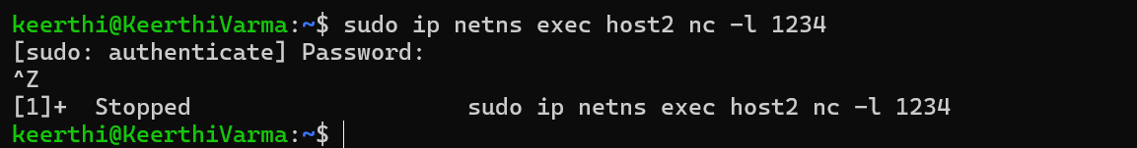
Terminal 5 - Connect from host1
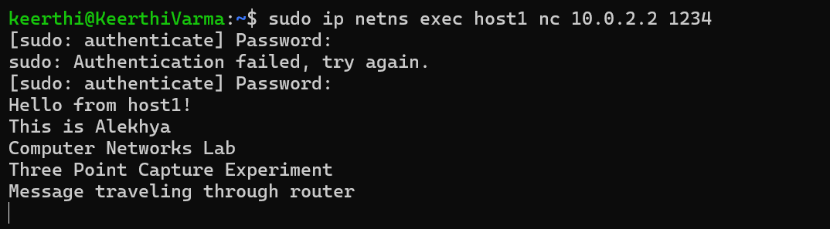
Terminal 4
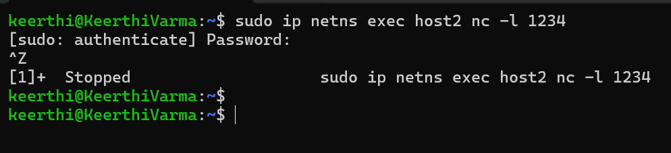
Terminal 3
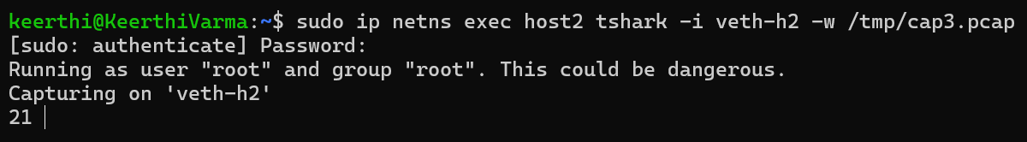

Terminal 2
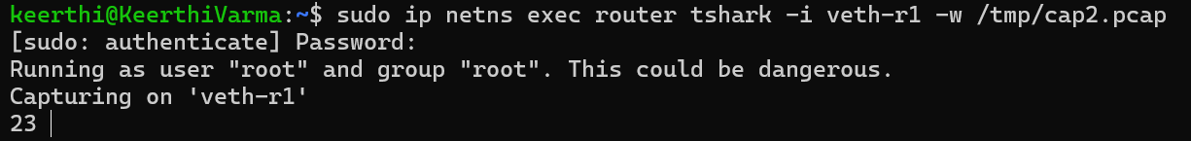
Terminal 1
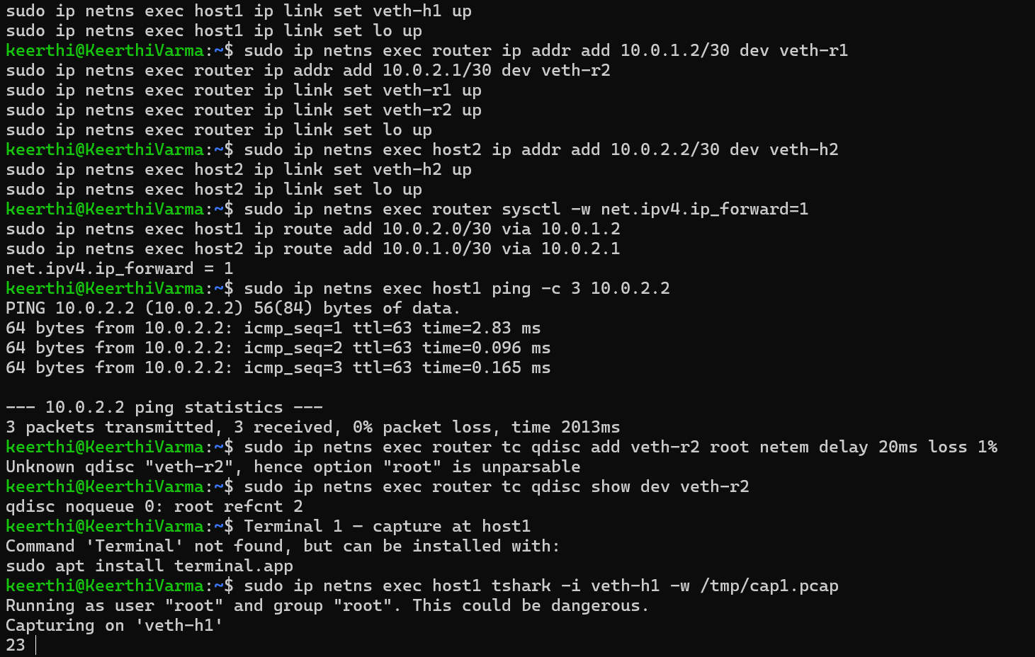
STAGE 12 — Fix permissions
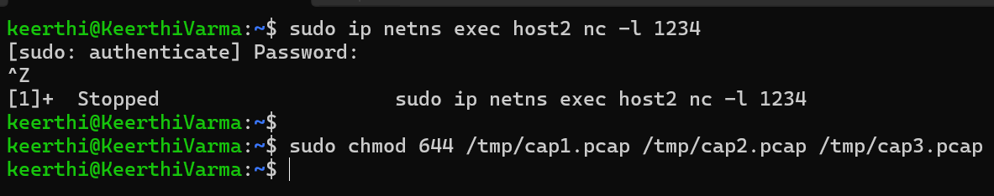
STAGE 13 — Check TTL
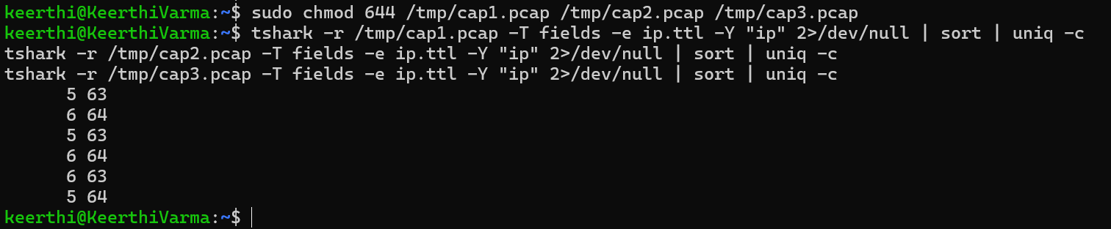

STAGE 14 — Read your actual message from the capture
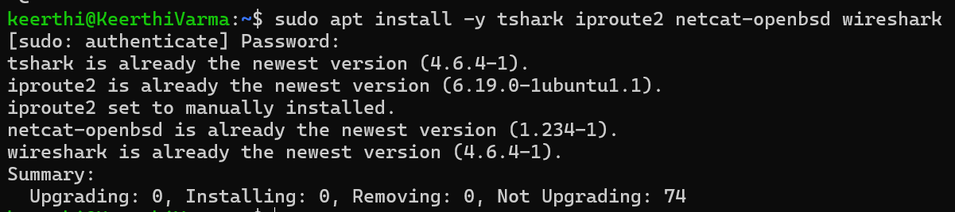
Create 3 nodes:
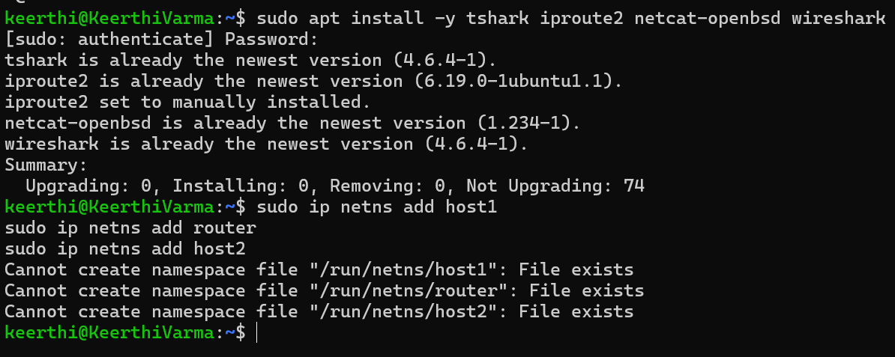
Create cables: 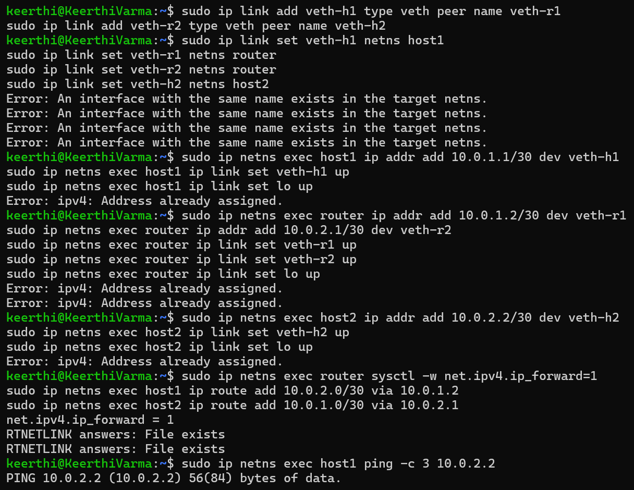
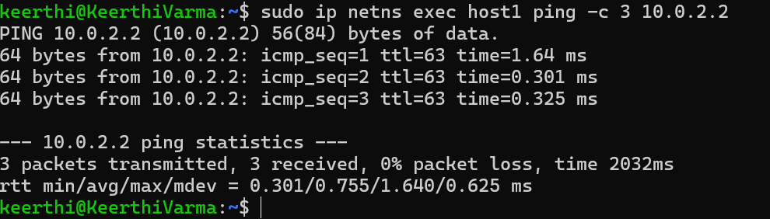
Add delay and loss:
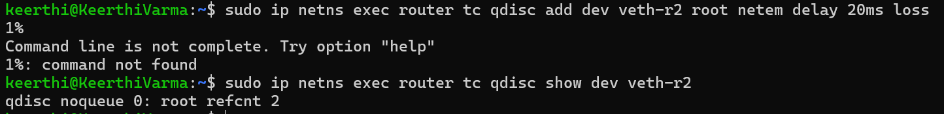
TERMINAL 1 — Capture at host1
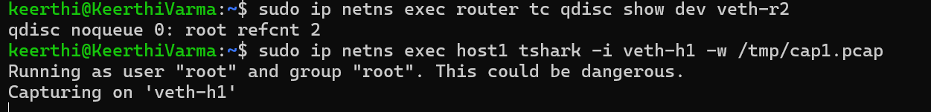
TERMINAL 2 — Capture at router
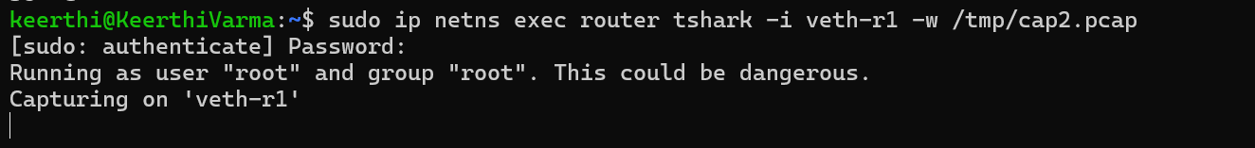
TERMINAL 3 — Capture at host2
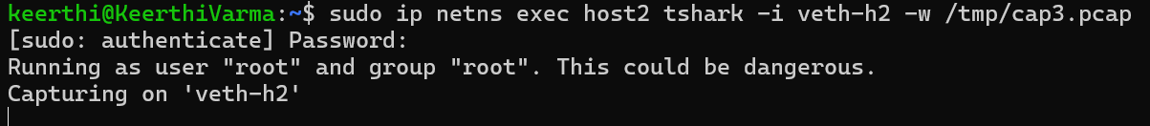
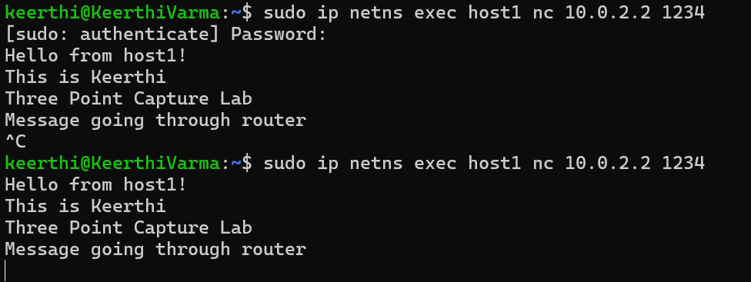

Step 6 — Press Ctrl+C in all terminals
TERMINAL 4 — Analyse results
Fix permissions:
Check files are not empty:
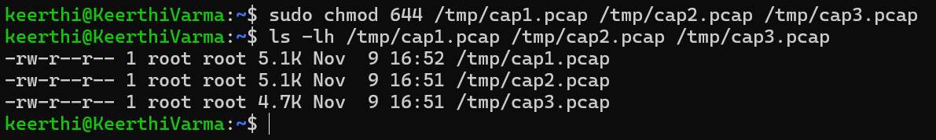
Check TTL at all 3 points:
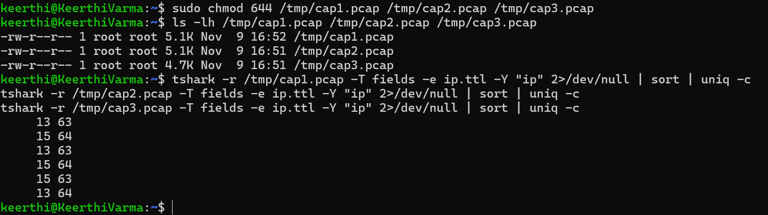
Read your actual message from router capture:
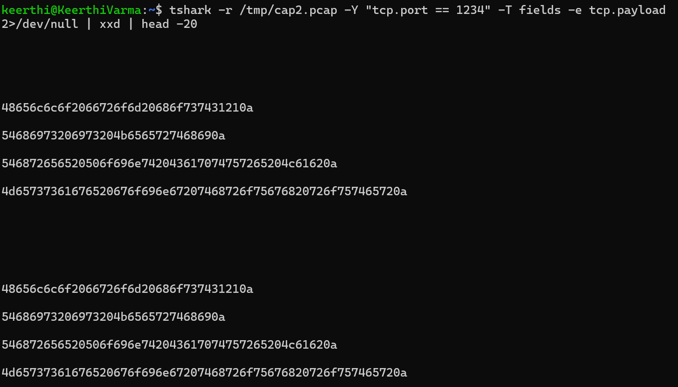

Check delay:
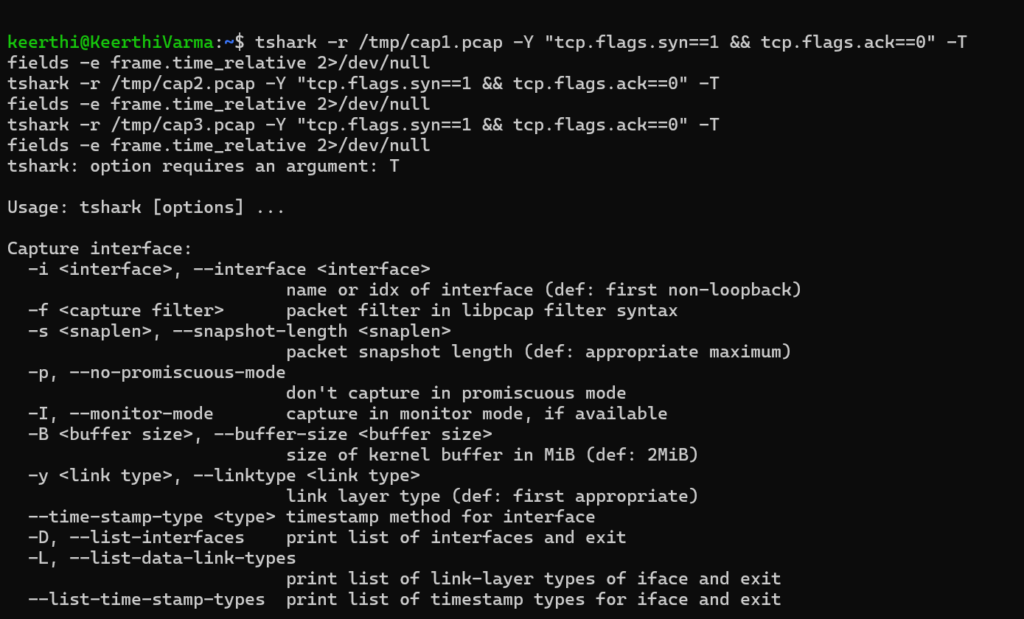
Check retransmissions:
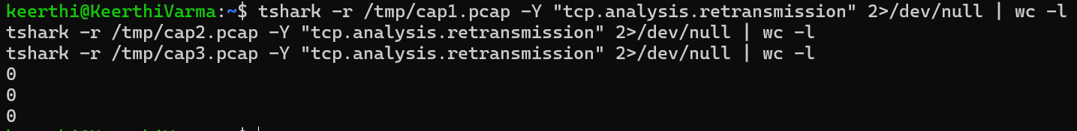
Check RTT:
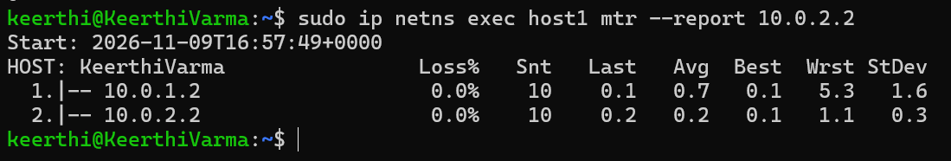

TERMINAL 4 — Open Wireshark


